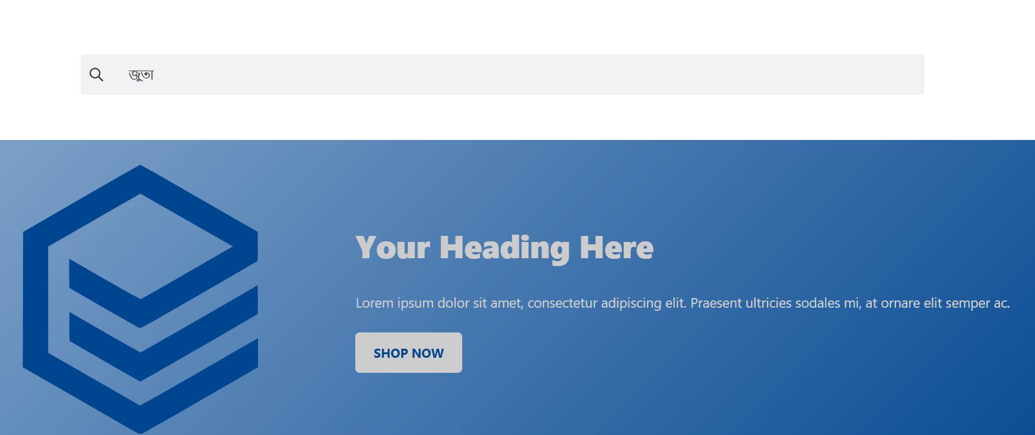

Test ID 11 : search bar is not providing any bengali suggestions